H.T No
Regulations:
A17


Sreenidhi Institute of Science and Technology
(An Autonomous Institution)
Code No: 6K402 Date: 28-Jan-2020 (FN)

B.Tech II-Year II-Semester External Examination, Jan/Feb - 2020 (Supplementary)
STRUCTURAL ANALYSIS-I (CIVIL)

Time: 3 Hours Max.Marks:75

Note: a) No additional answer sheets will be provided.
b) All sub-parts of a question must be answered at one place only, otherwise it will not be valued.
c) Missing data can be assumed suitably.

Part - A Max.Marks:25

Answer all QUESTIONS.

1. | Differentiate between determinate and indeterminate structures. | [3M]
2. | Define static and kinematic indeterminacies. | [3M]
3. | State and explain castinglono's theorem -I. | [3M]
4. | Explain internal and external indeterminacies in pin jointed trusses. | [3M]
5. | What do you understand from stiffness factors and distribution factors? | [3M]
6. | How do you calculate final moments in a frame? | [2M]
7. | How Kane's method is different from moment distribution method? | [2M]
8. | Explain carry over factors and final moments. | [2M]
9. | Explain elastic and rigid props. | [2M]
10. | Give the significance of sinking supports in fixed beams. | [2M]
Part – B Max.Marks:50
ANSWER ANY FIVE QUESTIONS. EACH QUESTION CARRIES 10 MARKS.

11. | a) | Determine the degrees of static indeterminacy and Kinematic inderminacy for the pin jointed plane truss shown in Fig.1  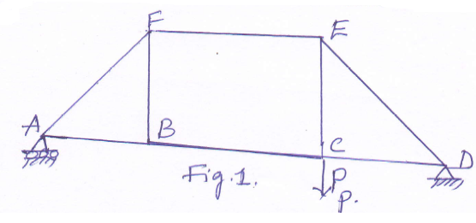 | [6M]
 | b) | Explain the equilibrium and compatibility equations | [4M]
12. | a) | Determine the forces and their nature in all the members of the pin jointed truss shown in fig.2  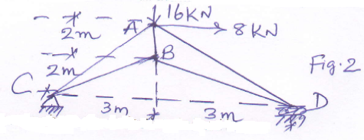 | [6M]
 | b) | Explain the procedure to obtain the deflections in fixed beams | [4M]
13. | a) | Analyze the beam using slope deflection method, and draw the shear force and bending moment diagrams shown in fig.3  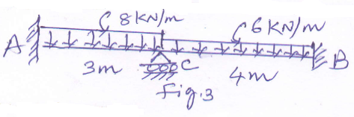 | [7M]
 | b) | How do you analyze portal frame explain? | [3M]
14. | a) | Analyze the beam shown in fig.4 by moment distribution method, Take EI is constant.  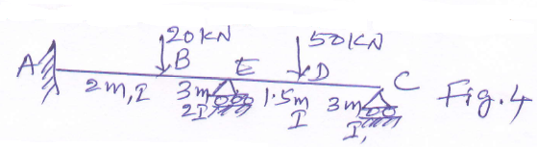 | [7M]
 | b) | Explain in brief fixed end moments with example. | [3M]
15. | a) | Analyze the frame by using Kape's method shown in fig.5  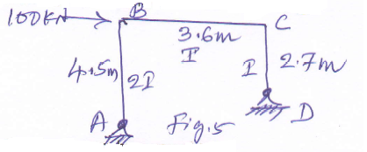 | [7M]
 | b) | Explain the rotation factors how you obtain | [3M]
16. | a) | Analyze the beam shown in figure 6 and draw the shear force and bending moment diagrams  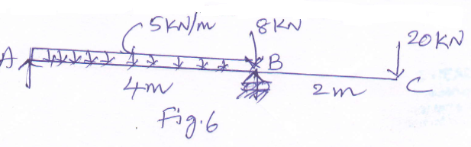 | [7M]
 | b) | Evaluate the fixed end moments for the beam shown in fig.7  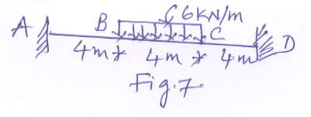 | [3M]
17. | a) | Explain indeterminate beams and frames | [3M]
 | b) | Find the forces in the truss shown in fig.8  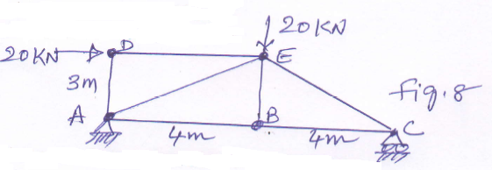 | [4M]
 | c) | Explain what you understand from the stiffness of the frame | [3M]
18. | a) | Explain the analysis of Single story and single bay frames | [3M]
 | b) | Explain the significance of prop reactions. | [2M]
 | c) | Analyze the beam shown in fig.9.  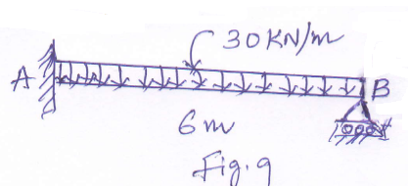 | [5M]

-- 00 -- 00 –

